Arduino Lesson 23
Trip-color LED RGB Module
Features：
Three groups of signal output Can achieve the effect of full color by mixing R G B 3 colors through the microcontroller programming.
Manufacture with RGB LED
3 output：
1. R，Red output,
2. G，Green output,
3. B，Blue output.
V connect to GND on UNO R3 board
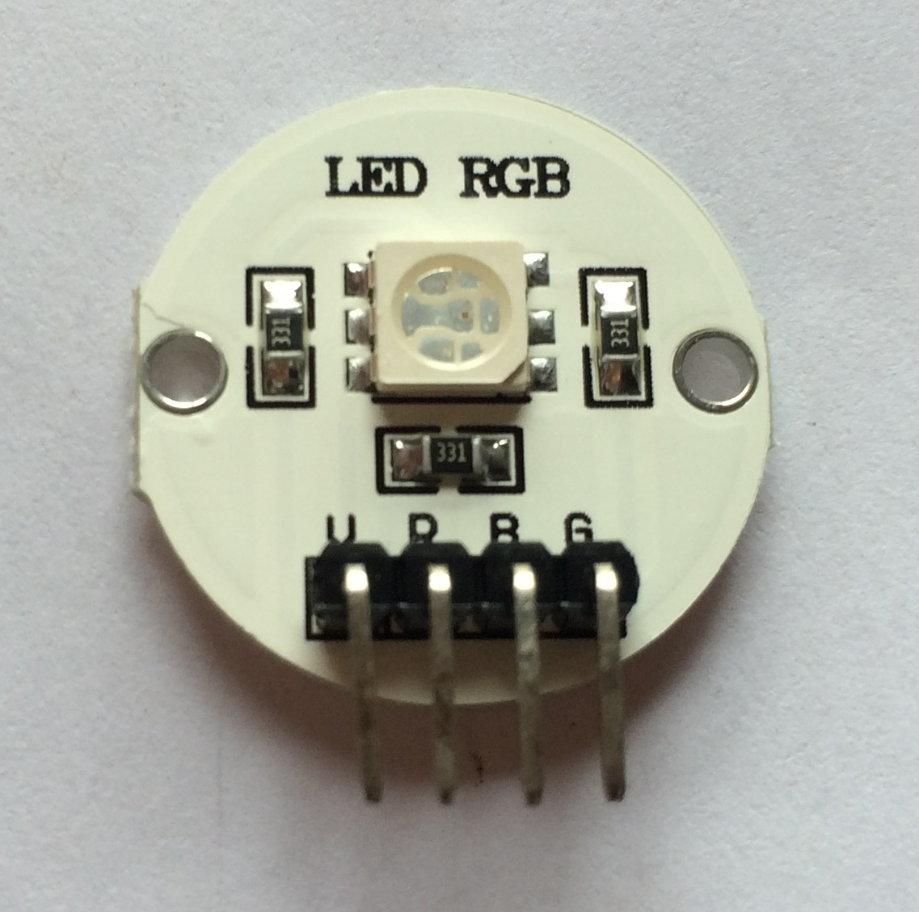
- Wiring
Please check the file “5050RGB Module Wiring.pdf” in folder “ Lesson 23 – RGB Module”

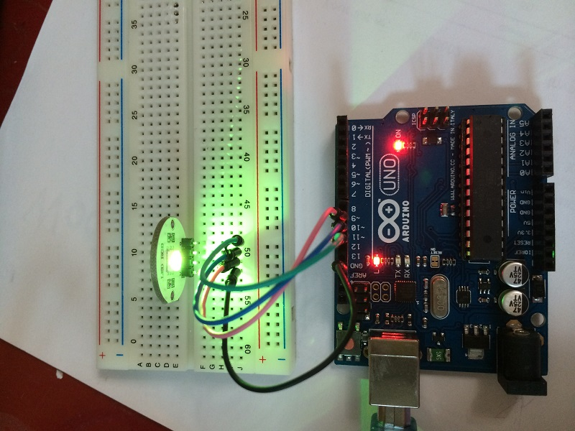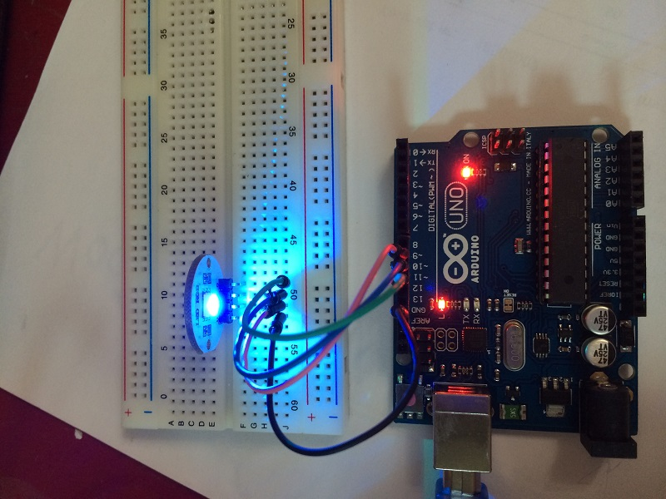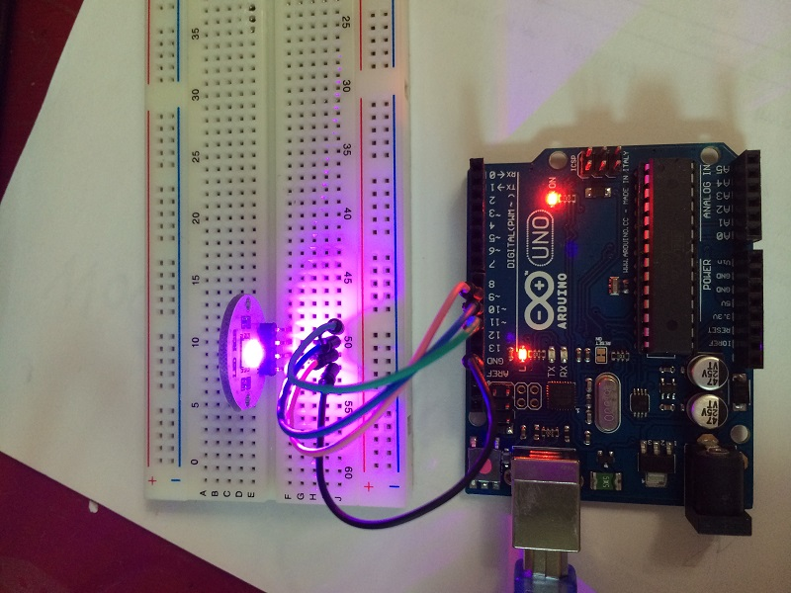
- Program for reference

Please open program “LED_RBG_H.pde” in folder “ Lesson 23 – RGB Module” and Upload, then you will see the LED start to blink.

